**Project Design Phase**

**Problem – Solution Fit Template**

|  |  |
| --- | --- |
| Date | 27 June 2025 |
| Team ID | LTVIP2025TMID35544 |
| Project Name | smartsdlc – AI-enhanced software development lifecycle |
| Maximum Marks | 2 Marks |

**Problem – Solution Fit :**

Traditional software development suffers from inefficiencies like manual requirement analysis, repetitive coding, time-consuming debugging, and inconsistent documentation. These bottlenecks slow down delivery and reduce collaboration between stakeholders. SmartSDLC addresses this by automating key SDLC stages using NLP and Generative AI, transforming unstructured inputs into actionable deliverables—code, tests, and documentation—accelerating development and enhancing accuracy at every step.

**Purpose:**

• Solve development inefficiencies by aligning AI automation with current SDLC workflows.

• Boost adoption by integrating with familiar tools like PDFs, natural language prompts, and code

• Enhance messaging with structured outputs like AI-generated user stories and documentation.

• Build trust by fixing pain points such as debugging delays and manual test case creation.

• Improve development practices by learning from real-world team behaviors and process gaps.

**Template:**

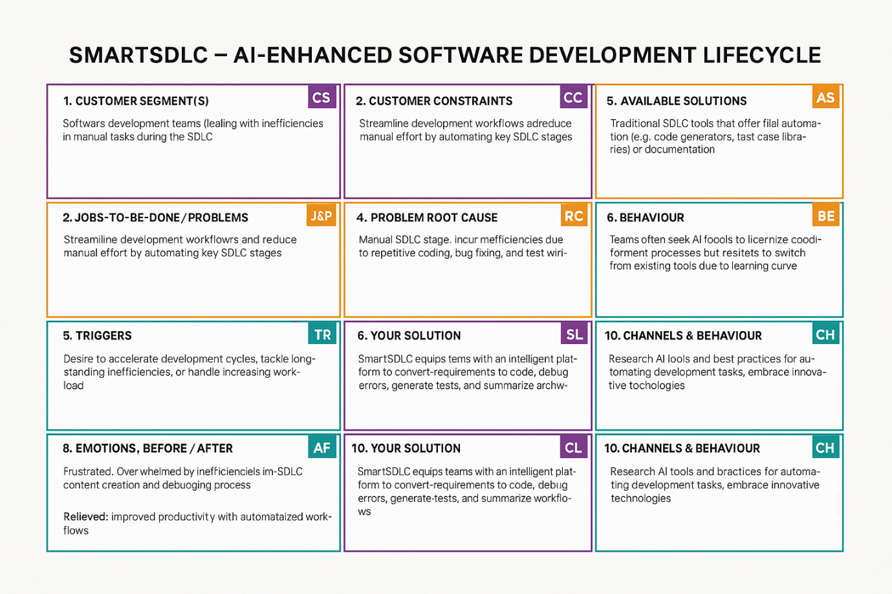

References:

1. <https://www.ideahackers.network/problem-solution-fit-canvas/>
2. <https://medium.com/@epicantus/problem-solution-fit-canvas-aa3dd59cb4fe>